**MICROSERVICES ASSIGNMENT**

**NEHA SHARMA**

**POSTMAN**

1. **FLIGHT_MICROSERVICE**

[**http://localhost:8081/api/flight/airline/inventory**](http://localhost:8081/api/flight/airline/inventory)

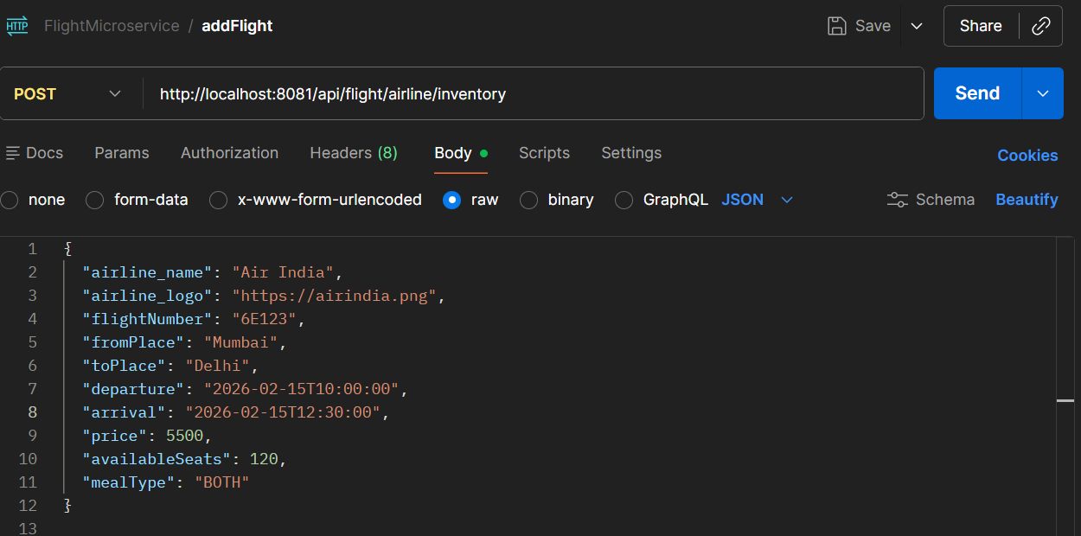

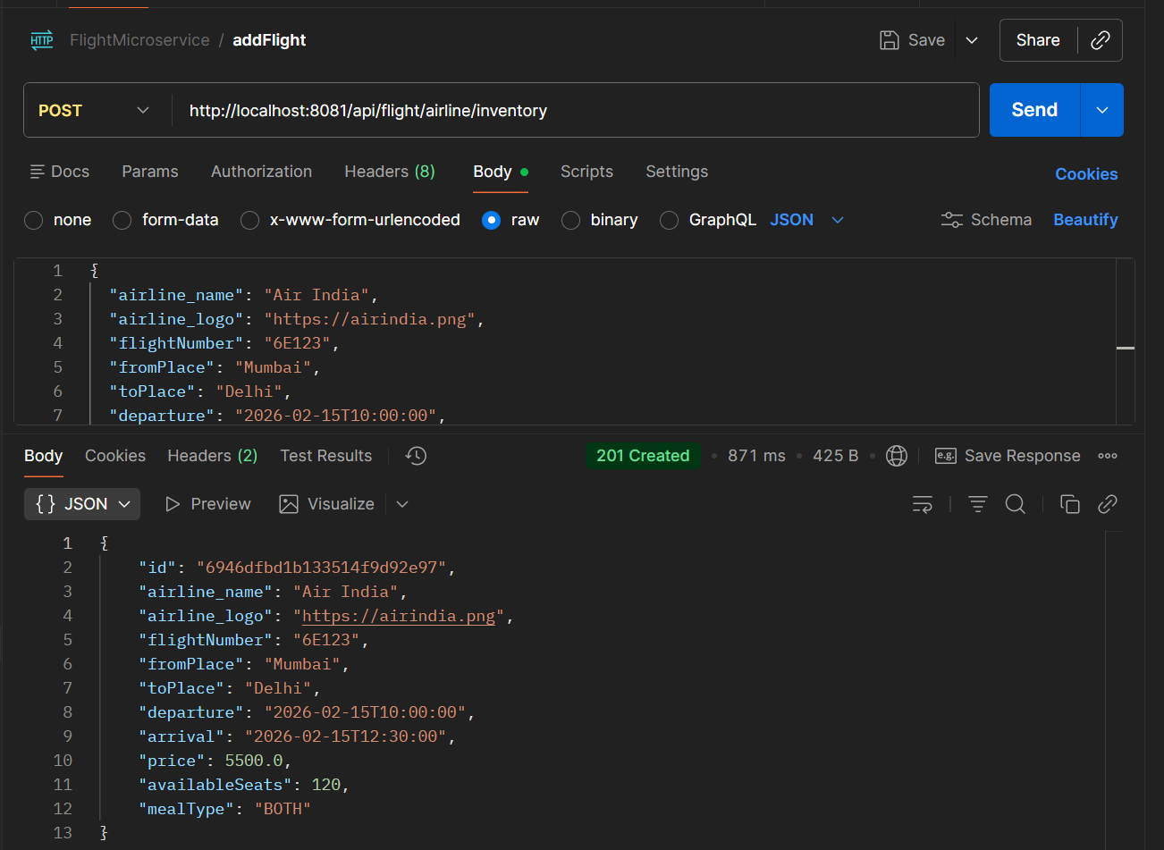

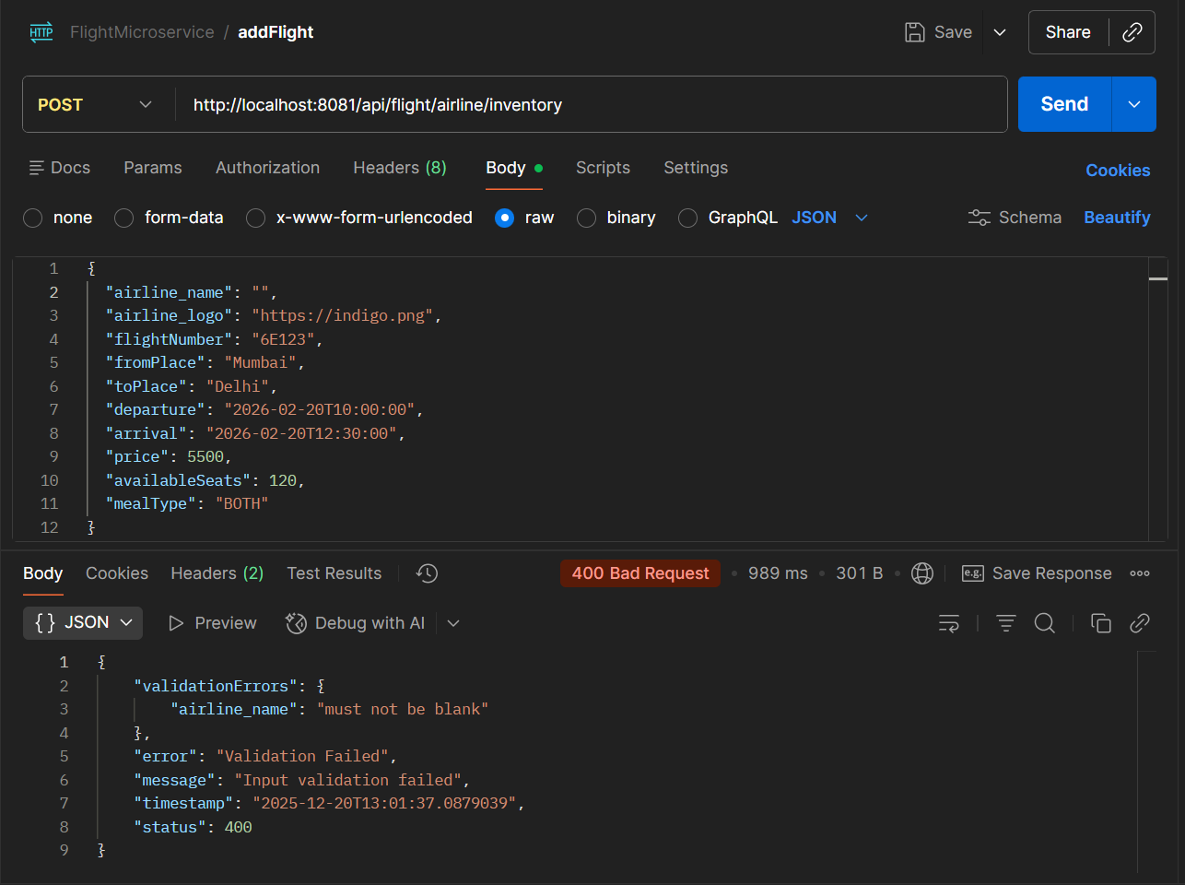

**http://localhost:8081/api/flight/search**

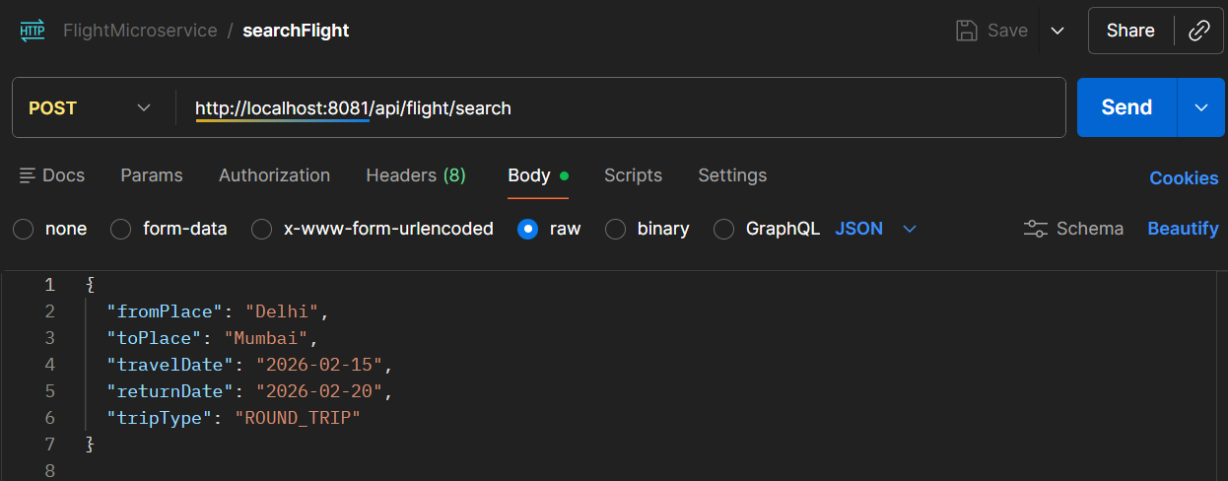

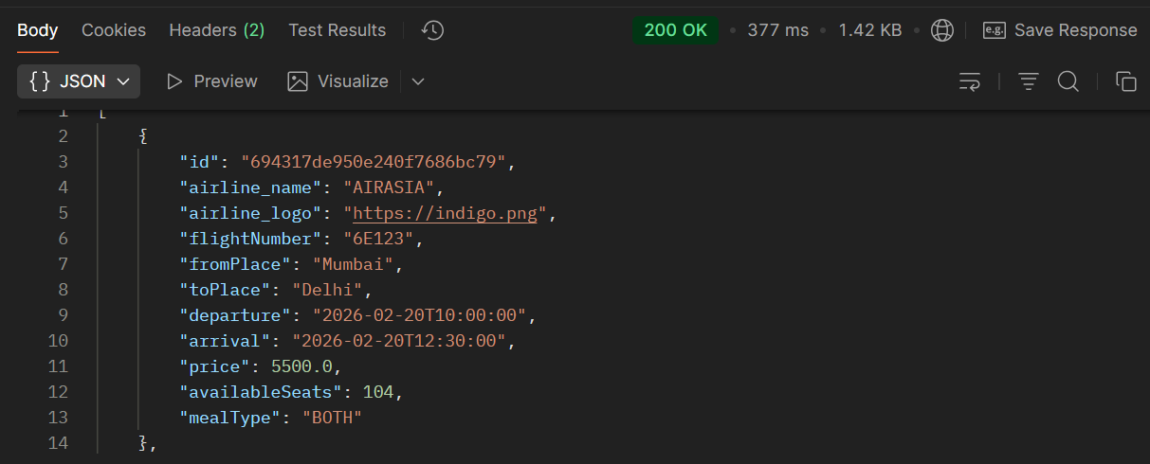

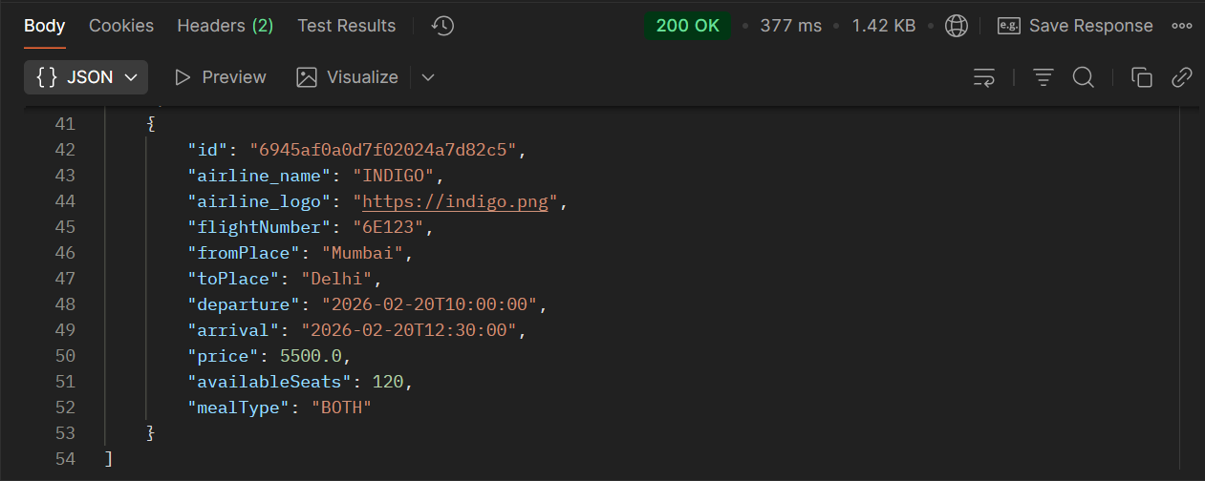

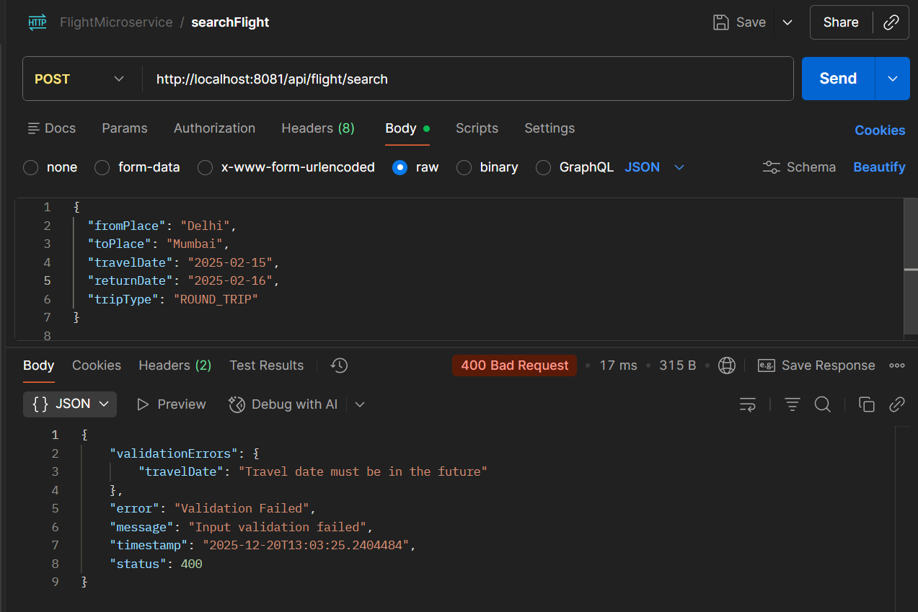

**http://localhost:8081/api/flight/airline/inventory/all**

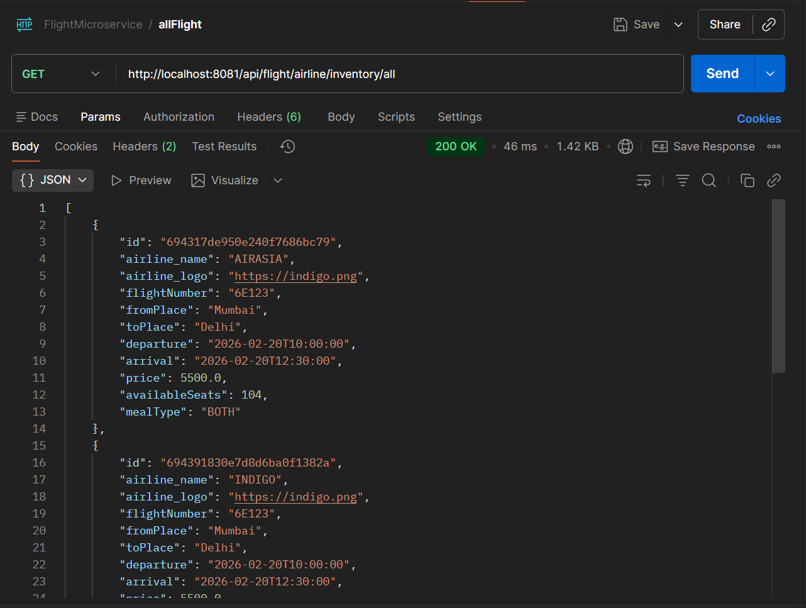

1. **BOOKING_MICROSERVICE**

**http://localhost:8082/api/flight/booking/694317de950e240f7686bc79**

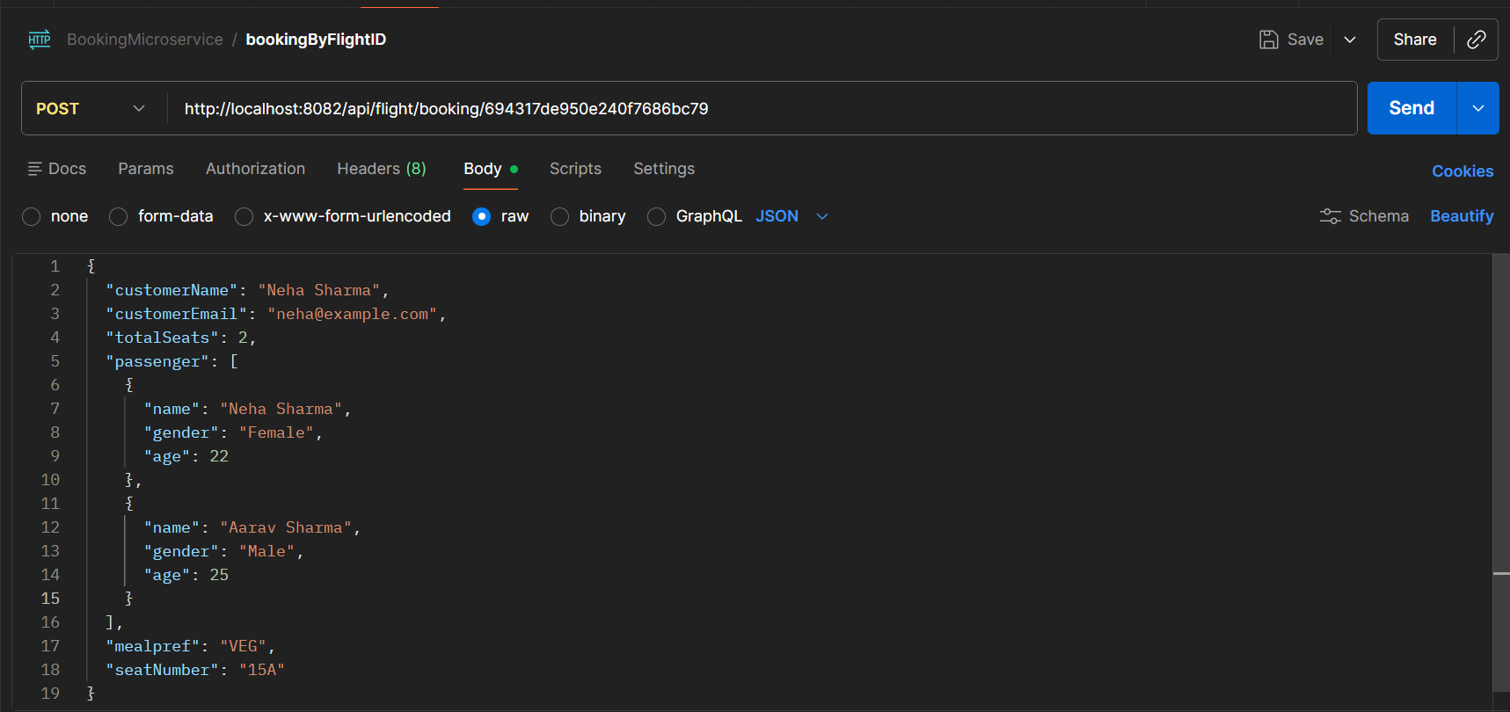

OUTPUT:

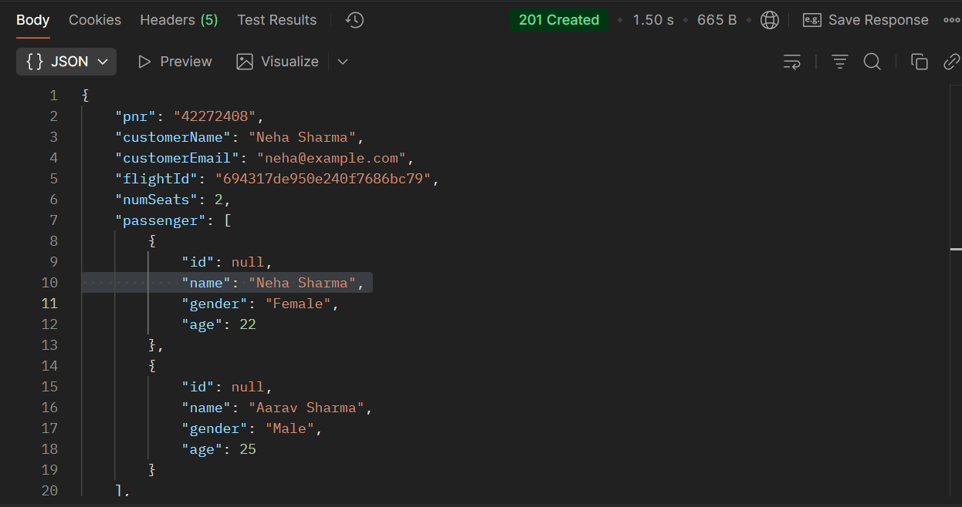

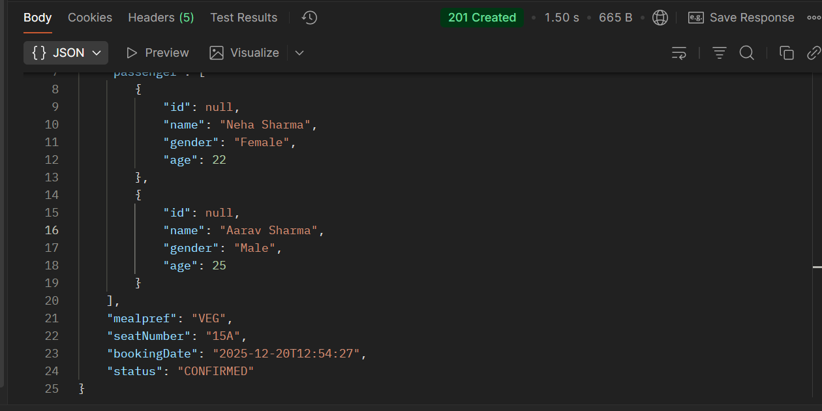

**http://localhost:8082/api/flight/ticket/B3ECE00C**

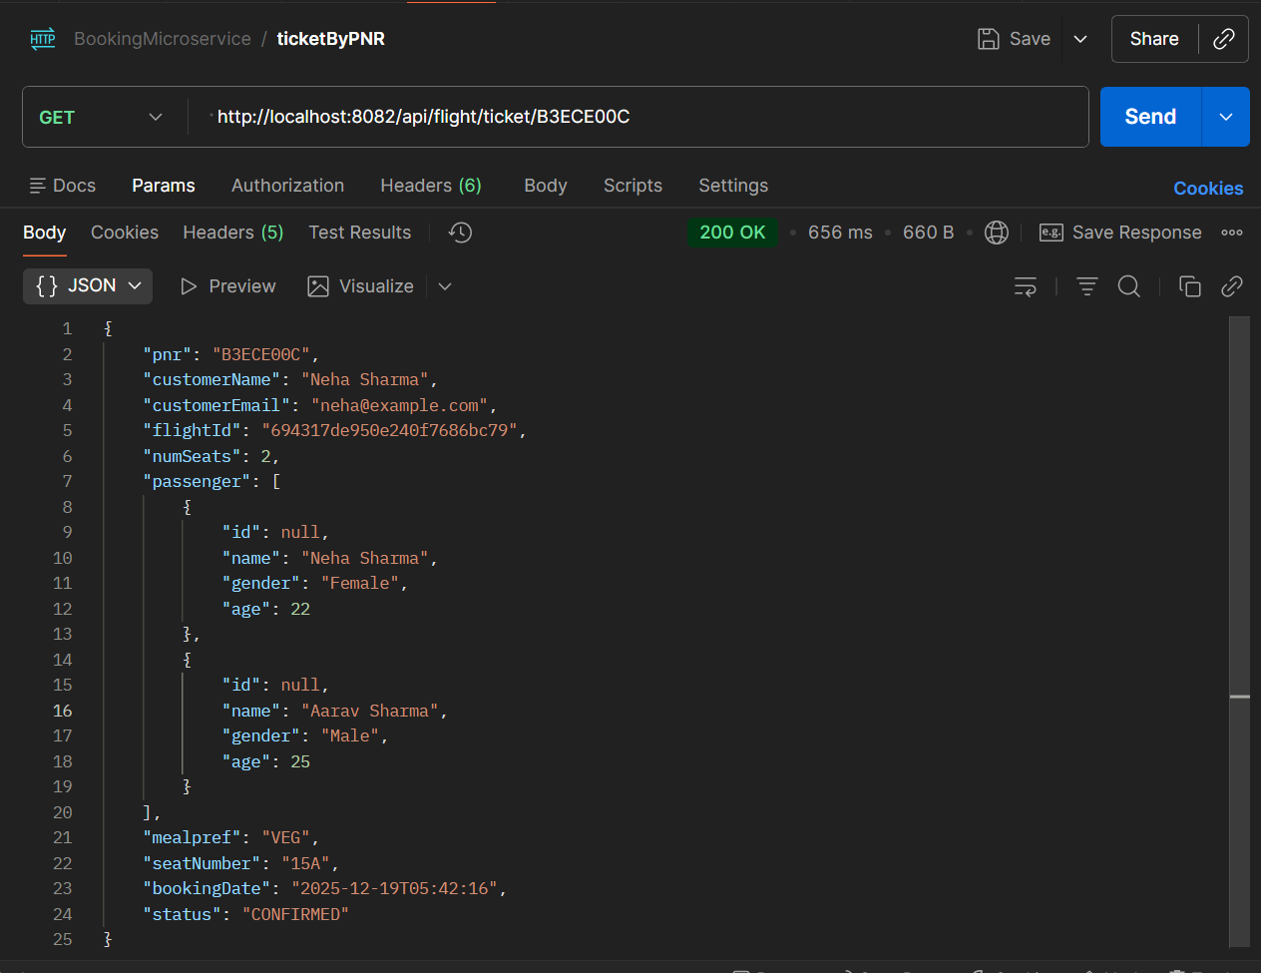

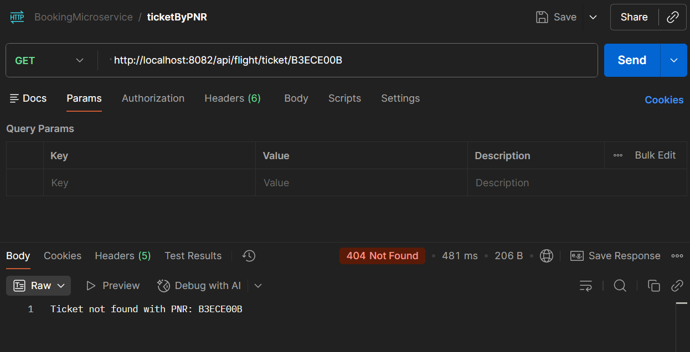

**http://localhost:8082/api/flight/booking/history/neha@gmail.com**

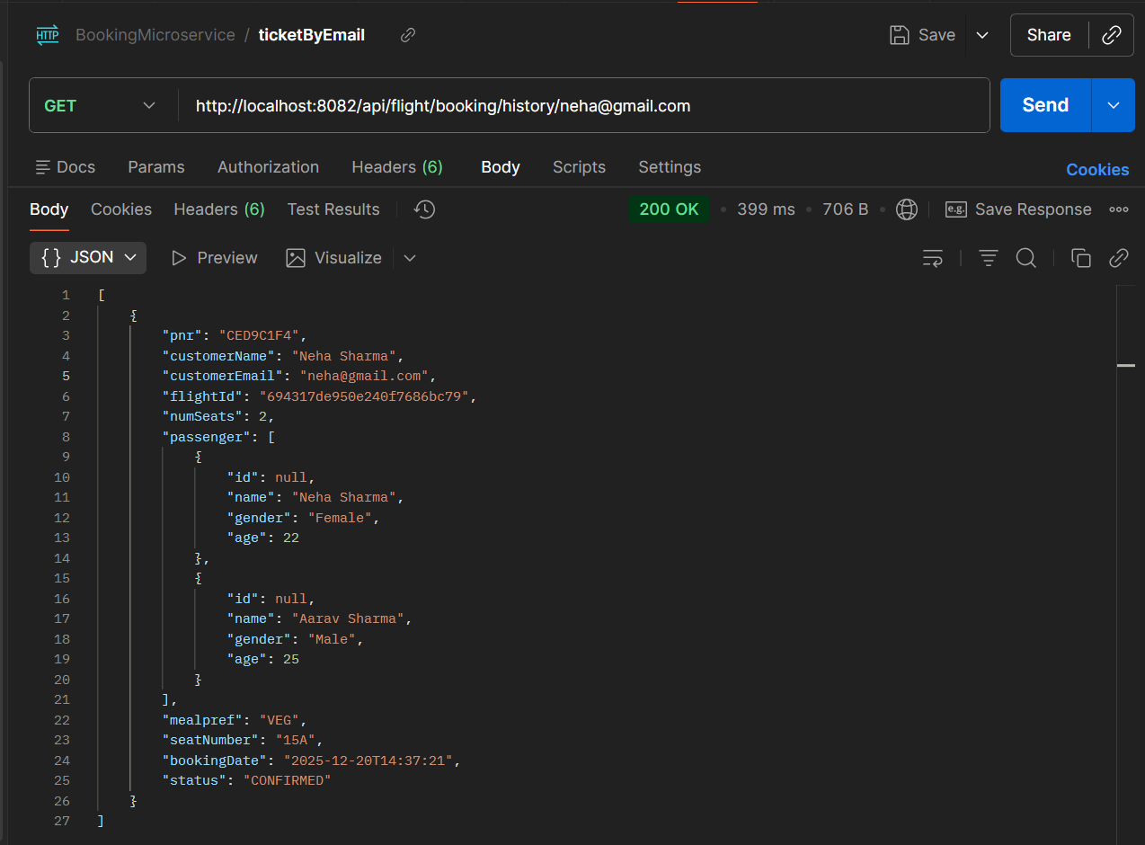

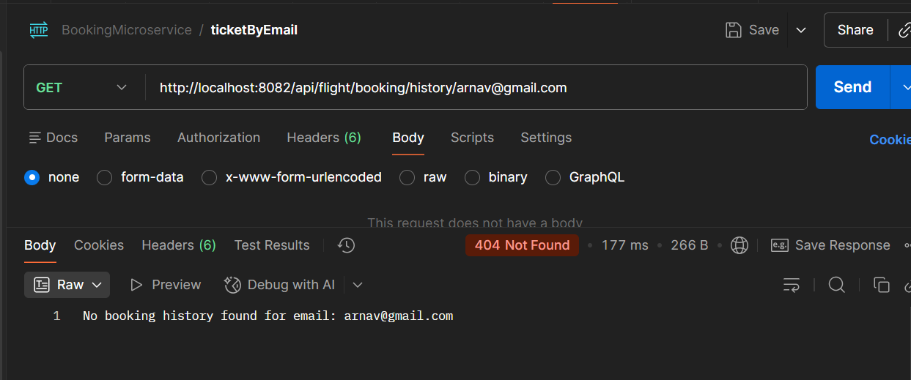

**http://localhost:8082/api/flight/booking/cancel/7987240E**

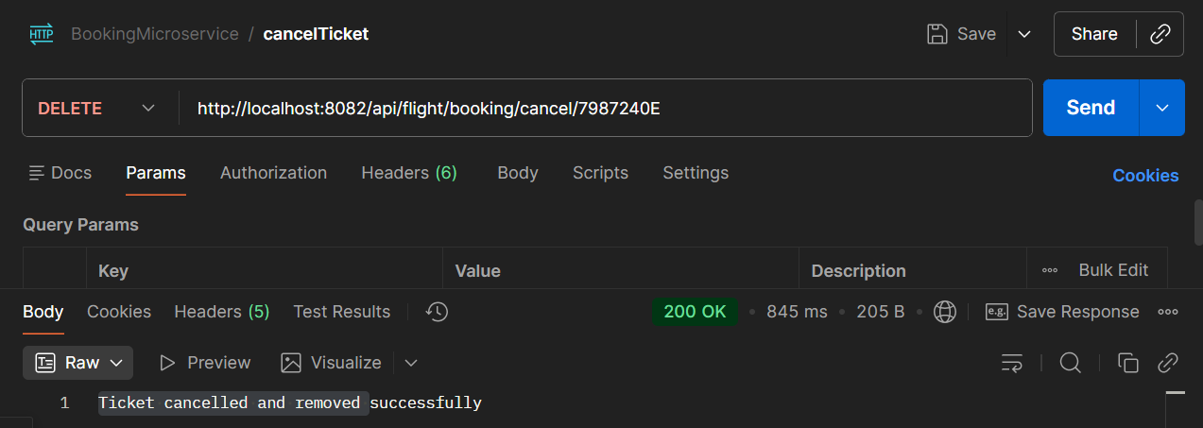

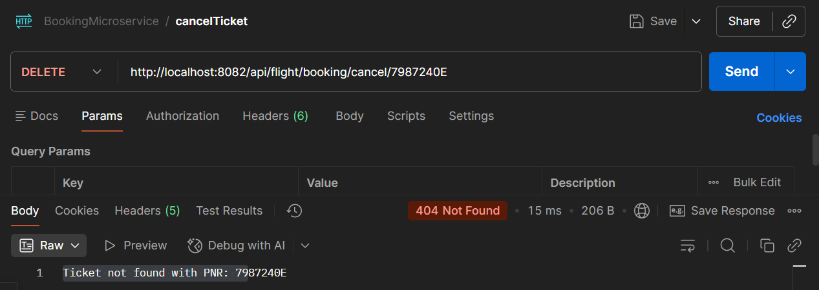

1. **API_GATEWAY**

**http://localhost:8091/microservice-flightservice/api/flight/airline/inventory**

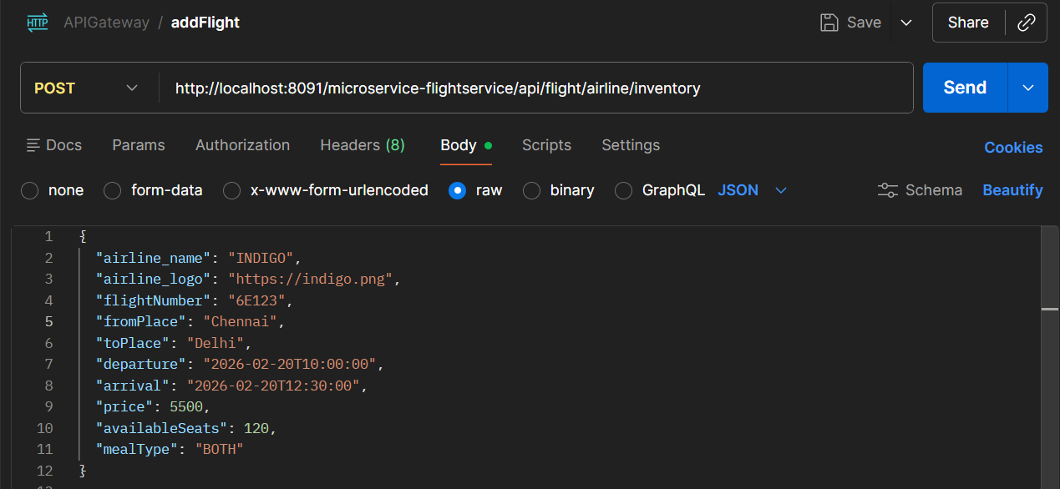

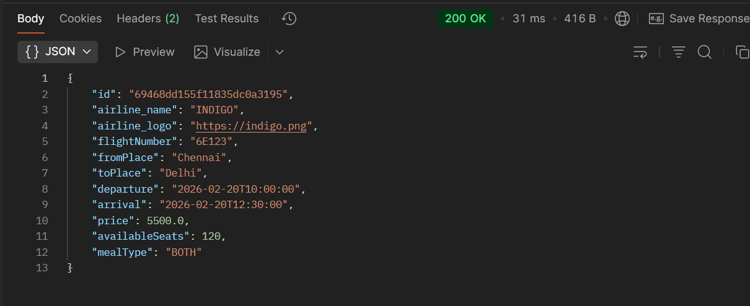

**http://localhost:8091/microservice-flightservice/api/flight/search**

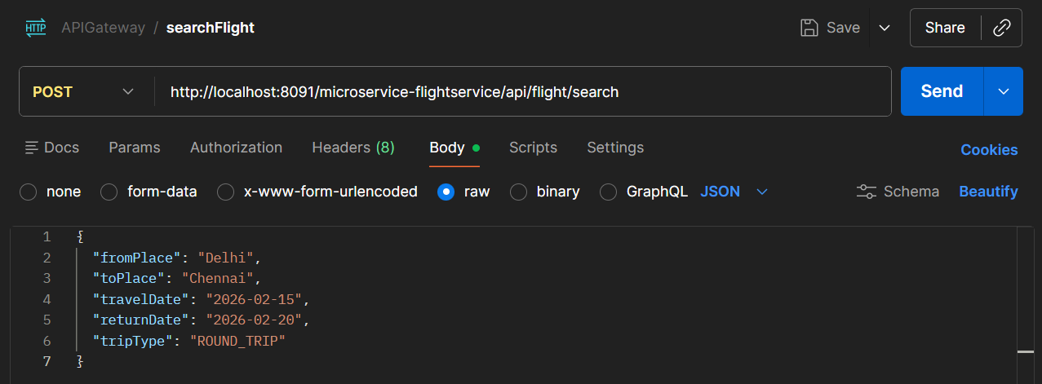

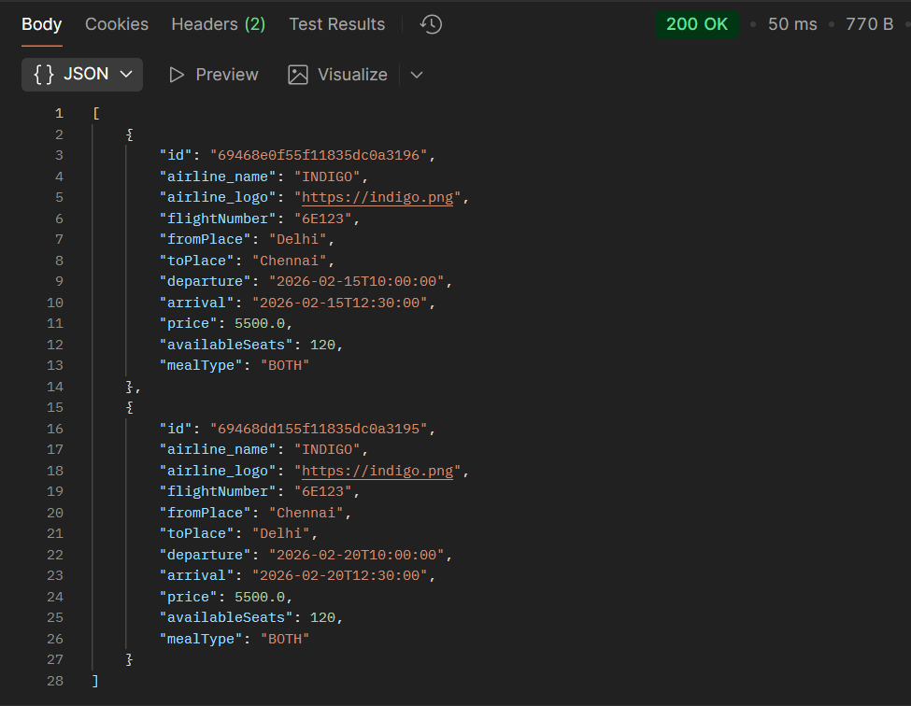

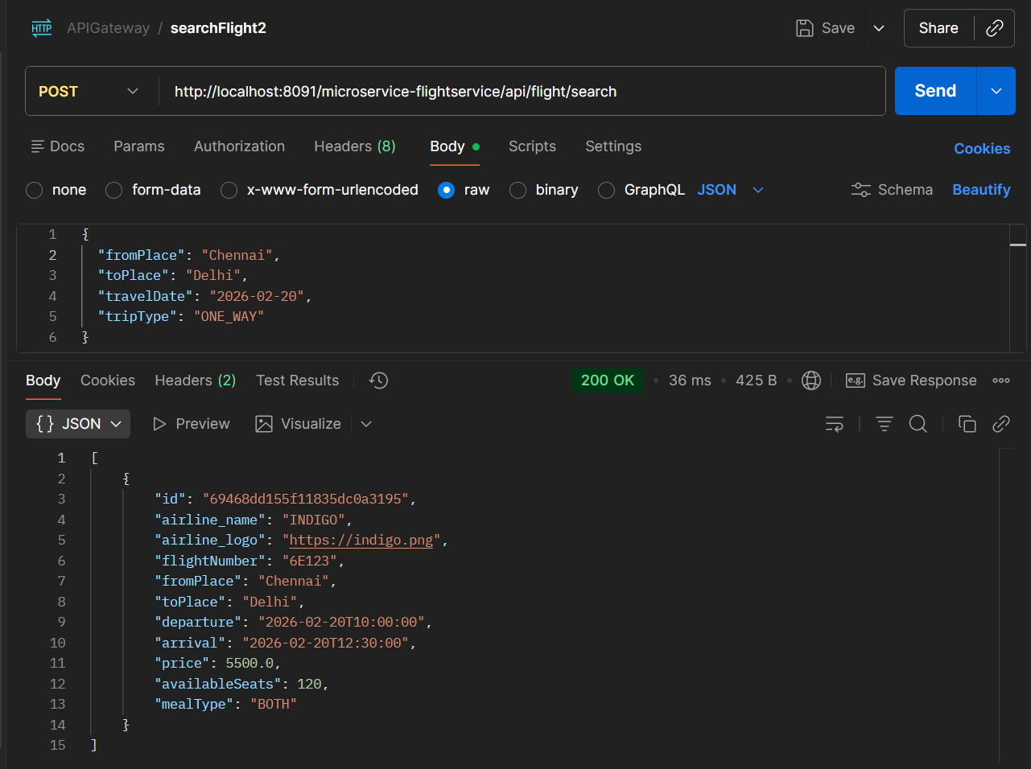

**http://localhost:8091/microservice-flightservice/api/flight/airline/inventory/all**

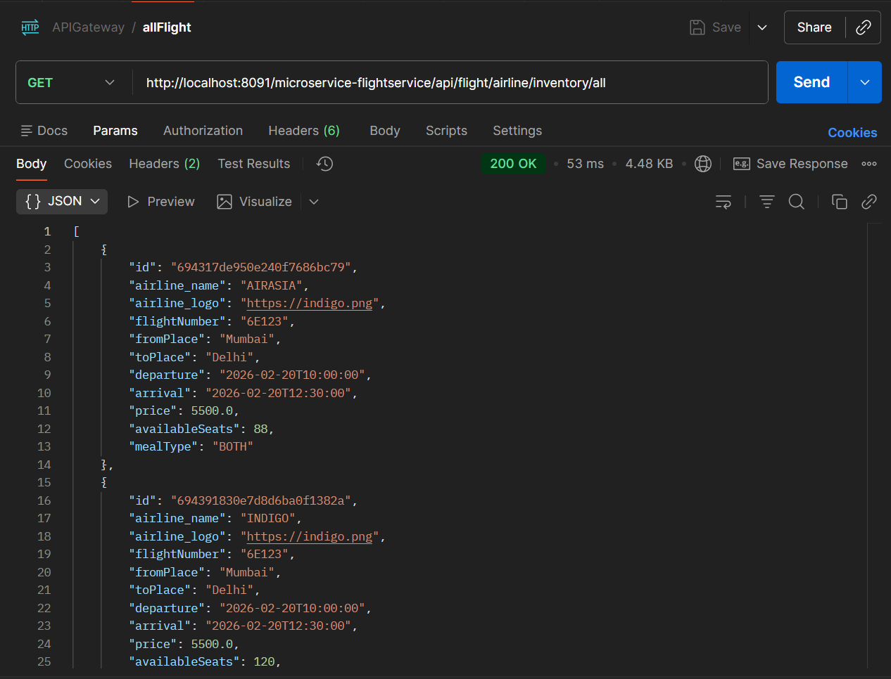

**http://localhost:8091/microservice-bookingservice/api/flight/booking/694317de950e240f7686bc79**

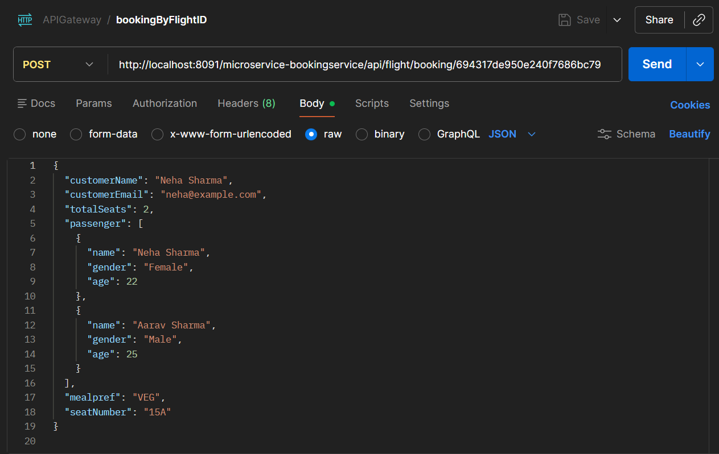

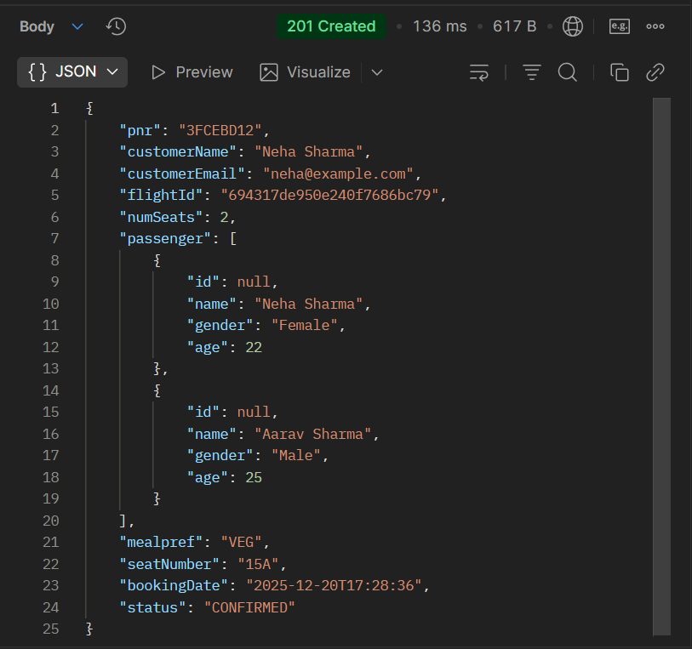

**http://localhost:8091/microservice-bookingservice/api/flight/ticket/3FCEBD12**

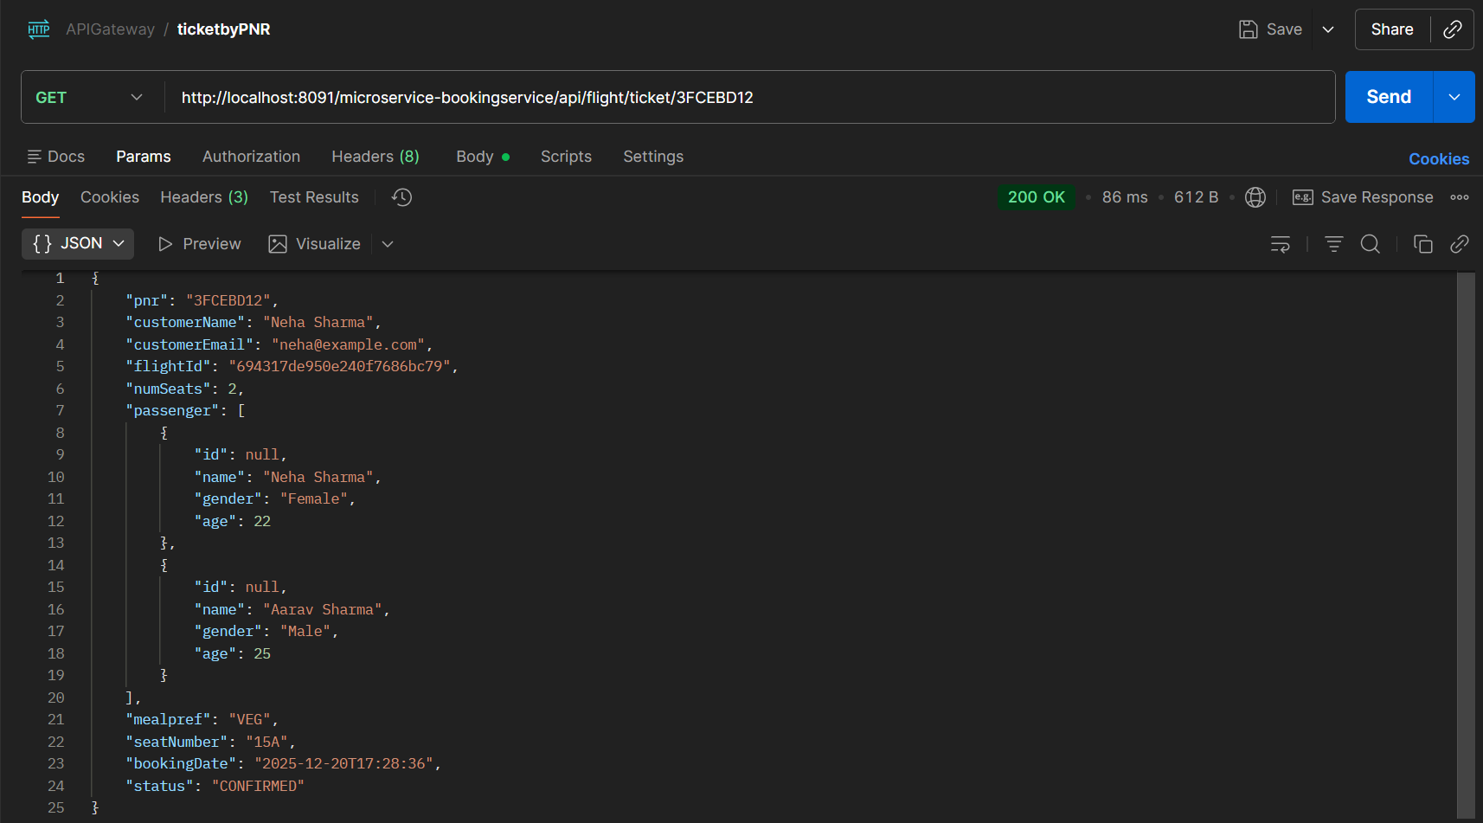

**http://localhost:8091/microservice-bookingservice/api/flight/booking/history/rmneha@gmail.com**

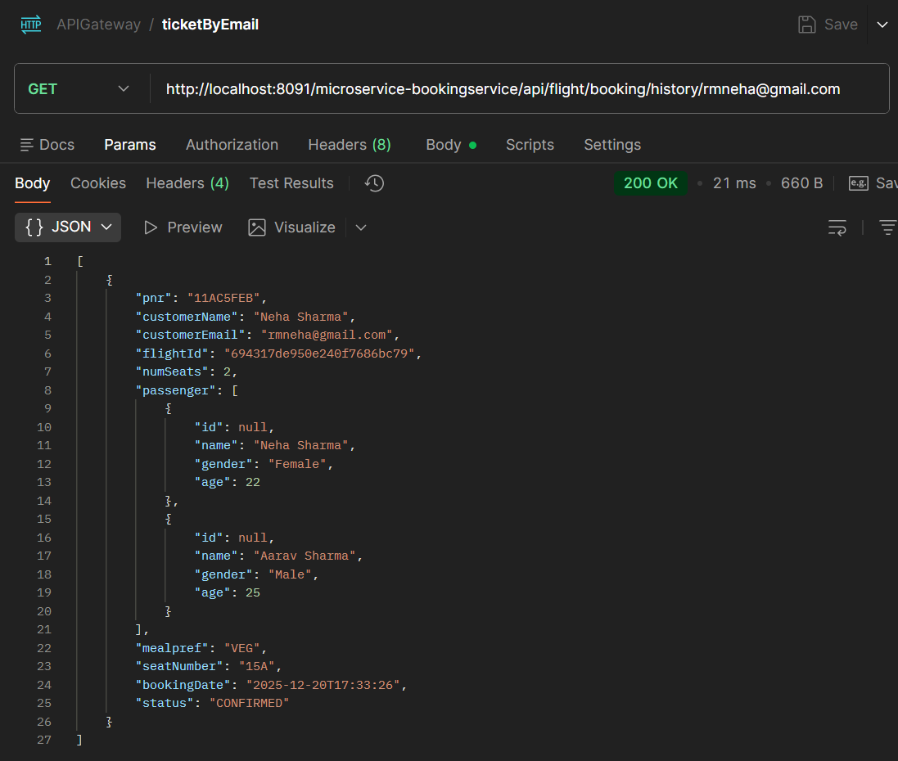

**http://localhost:8091/microservice-bookingservice/api/flight/booking/cancel/11AC5FEB**

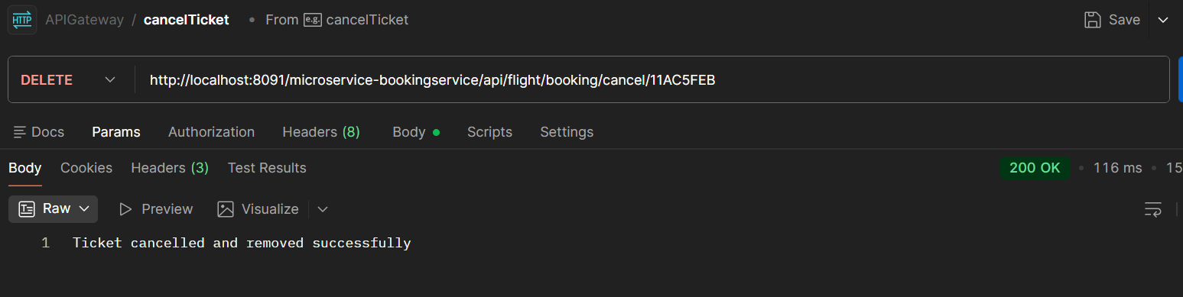

1. **NewMan (POSTMAN using CLI )**

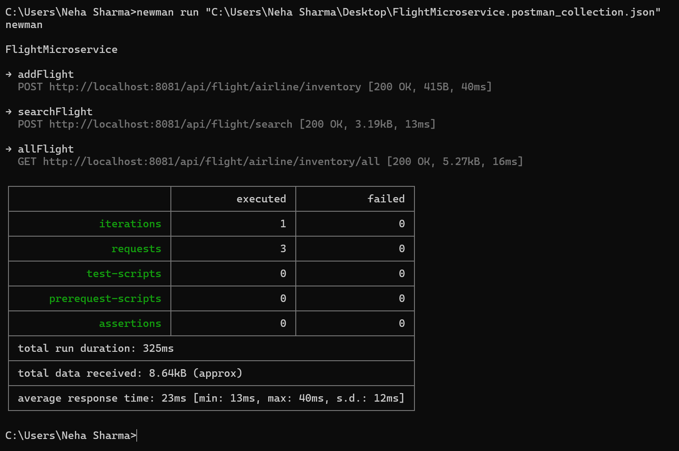

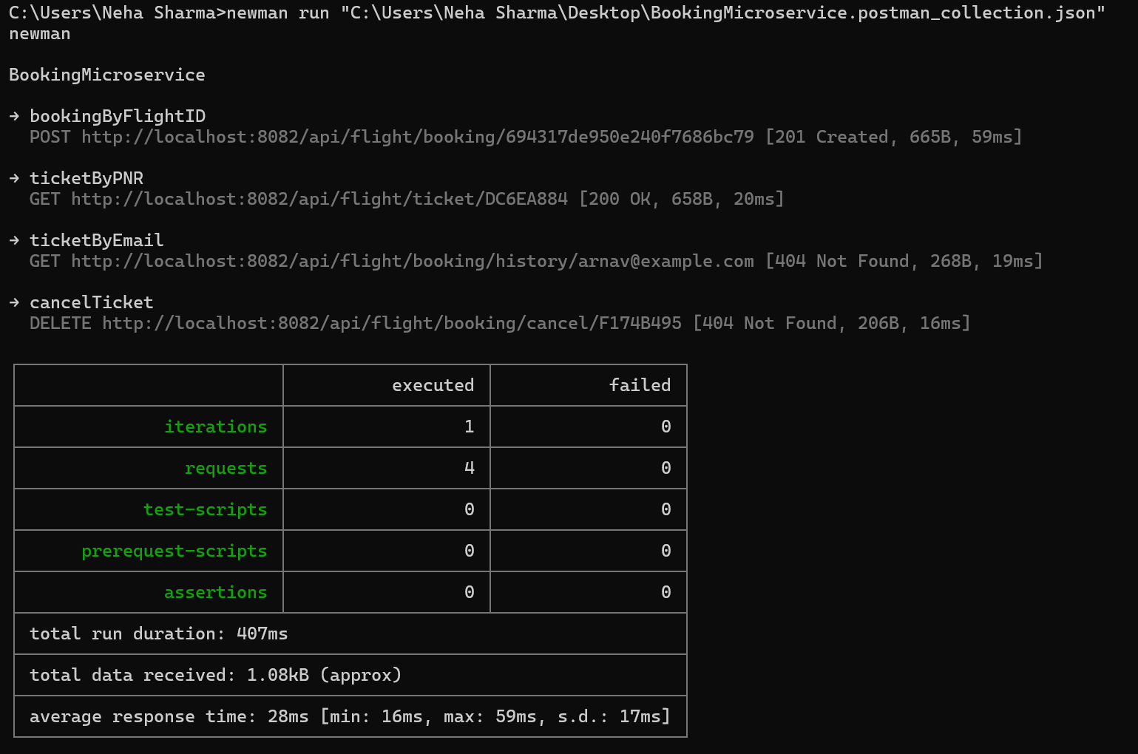

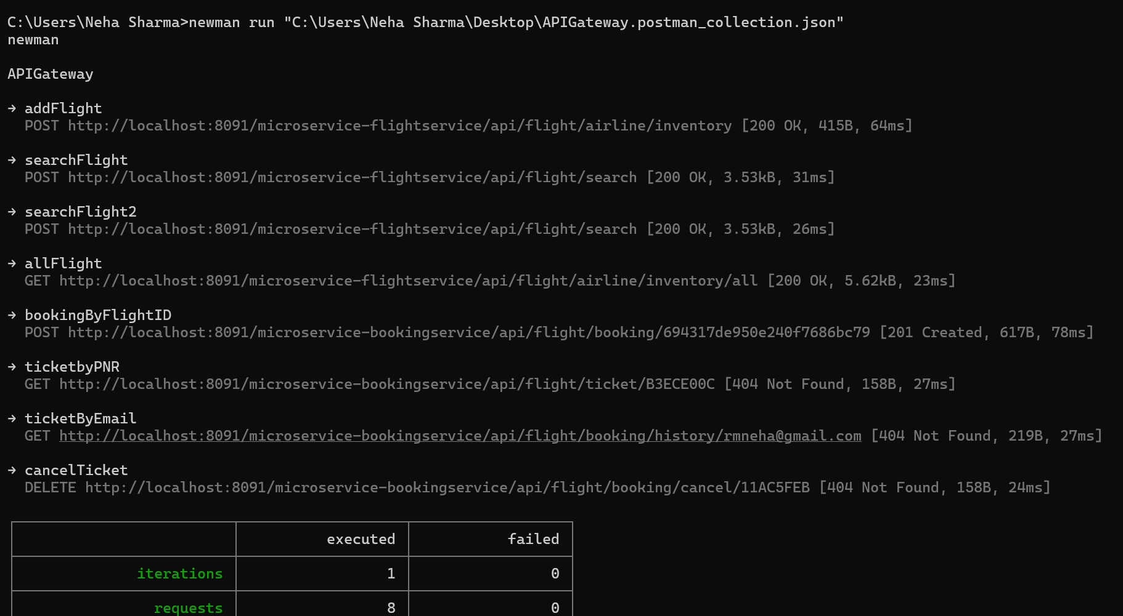

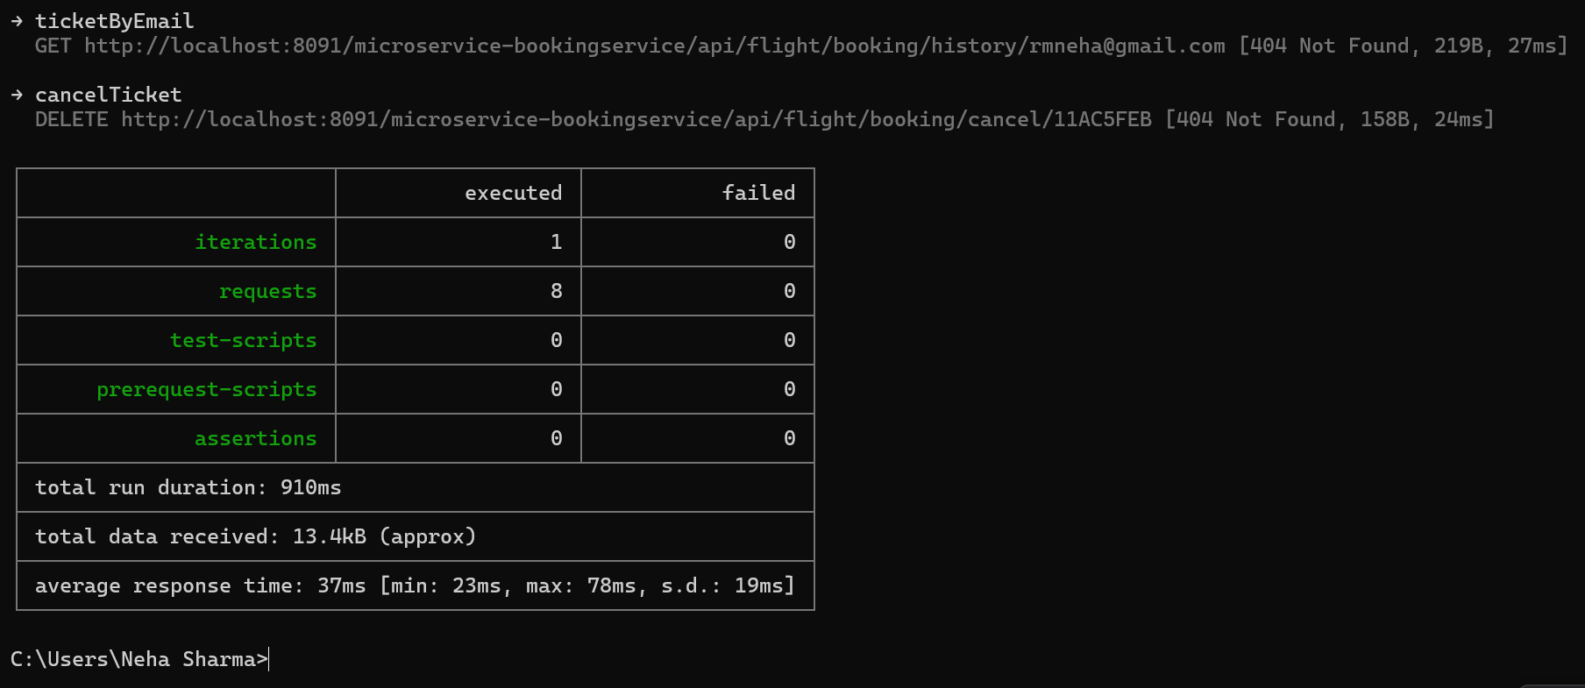

1. **Eureka Integration**

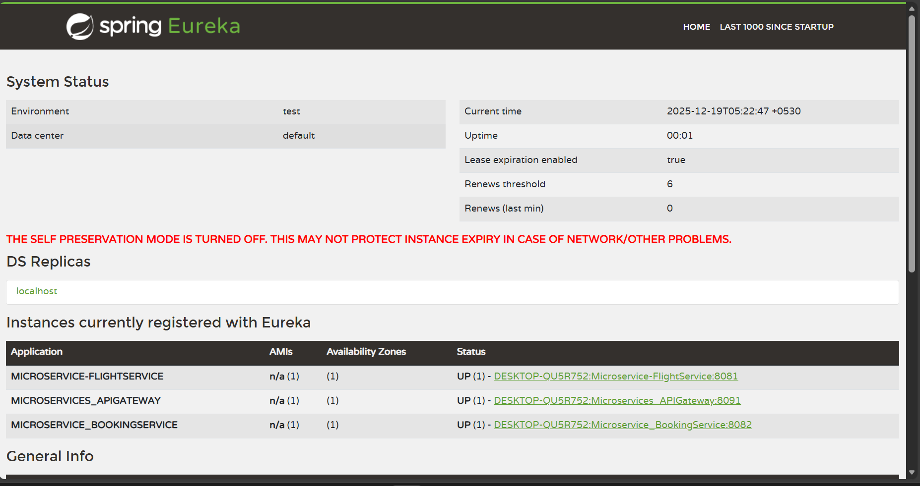

1. **Circuit Breaker**

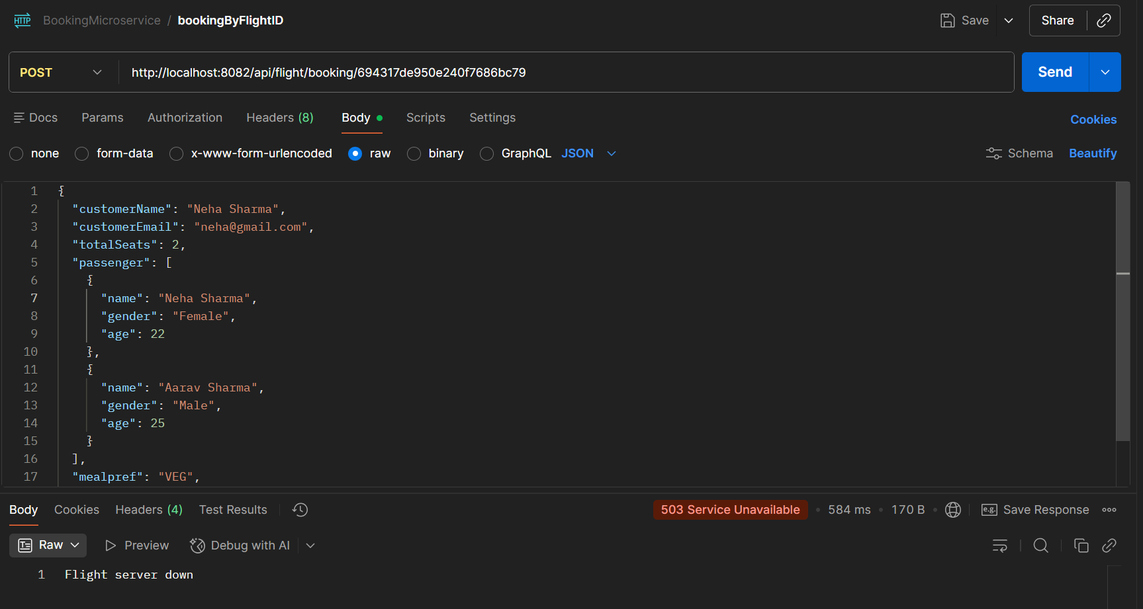

1. **Message Broker (KAFKA+ MailHog)**

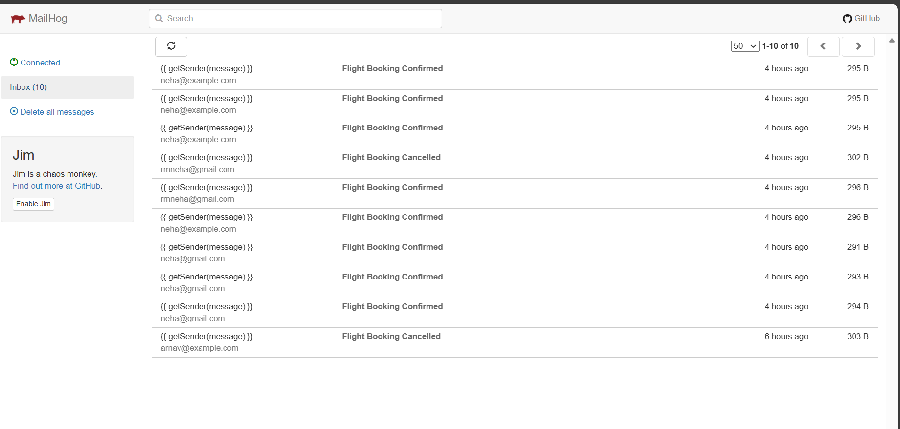

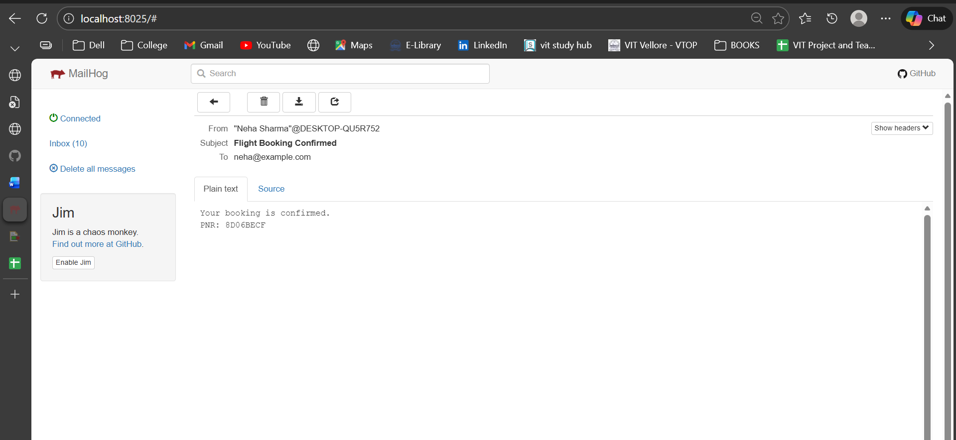

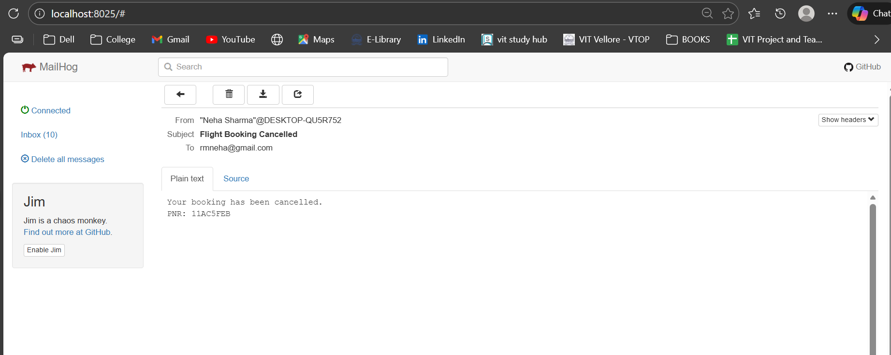

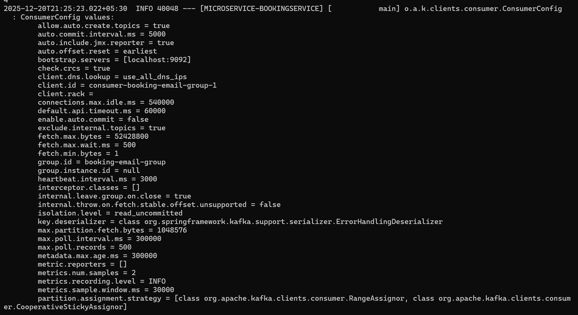

1. **JACOCO REPORT**
2. **Booking Service**

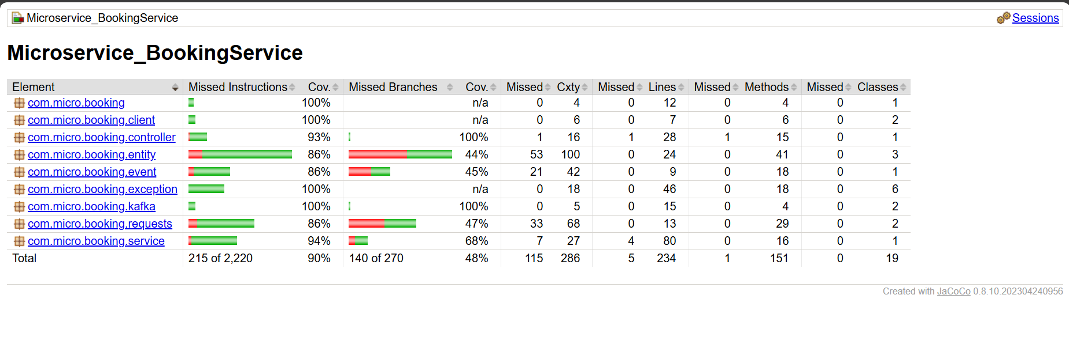

1. **Flight Service**

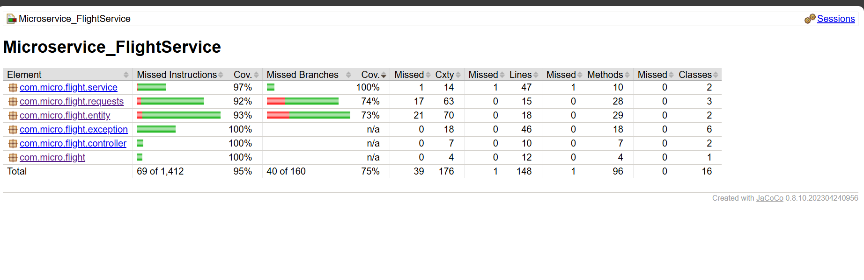

1. **SONARCUBE**

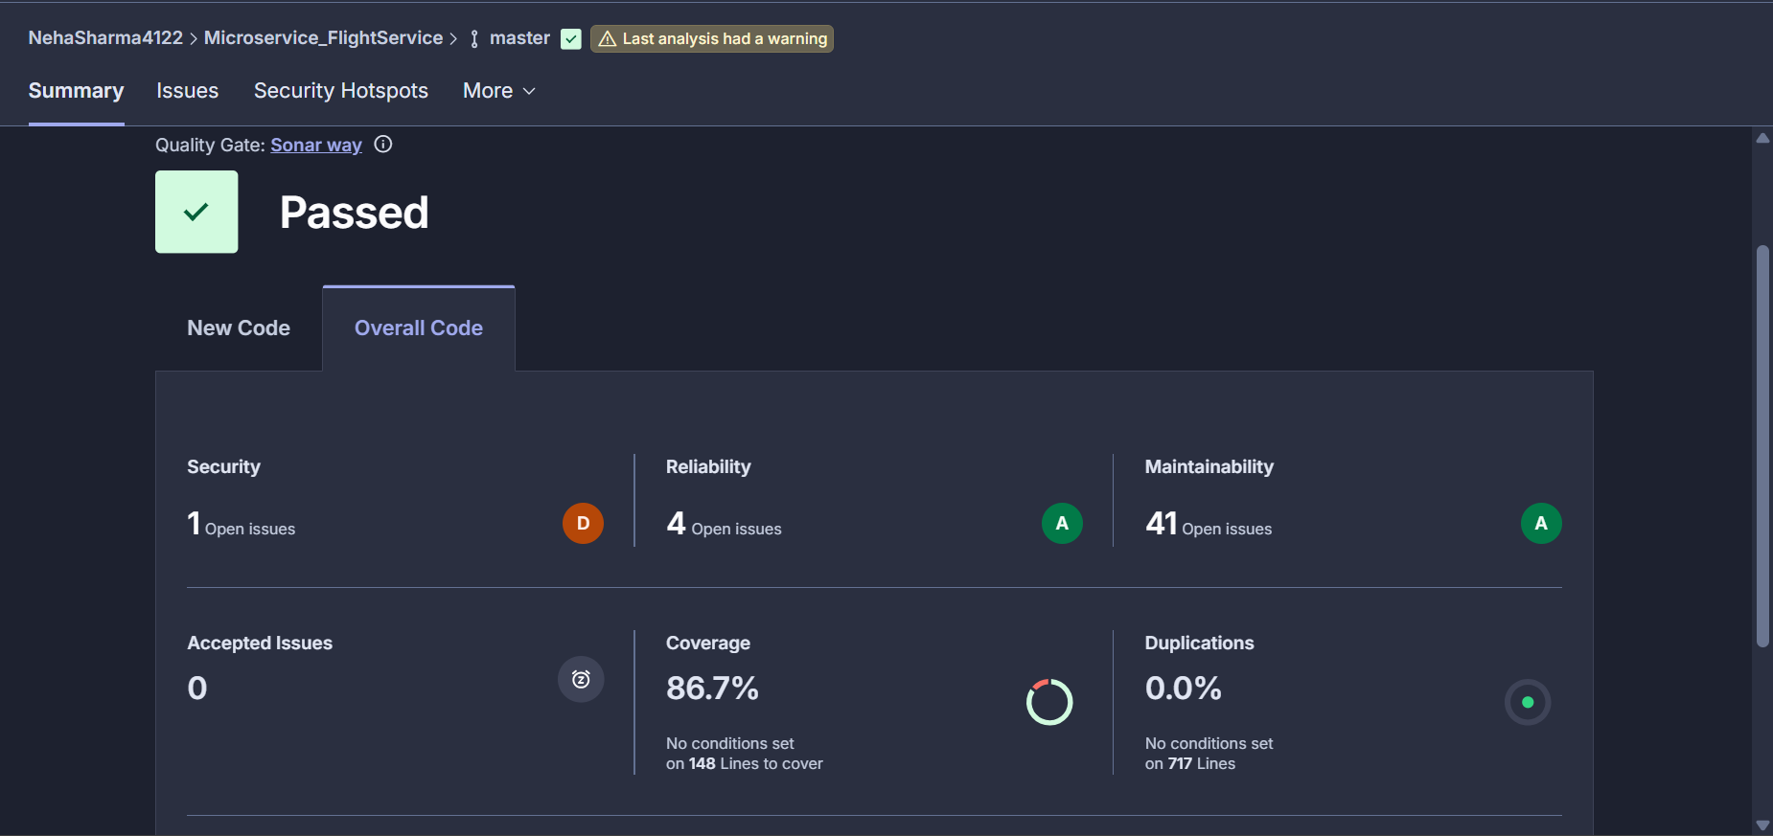

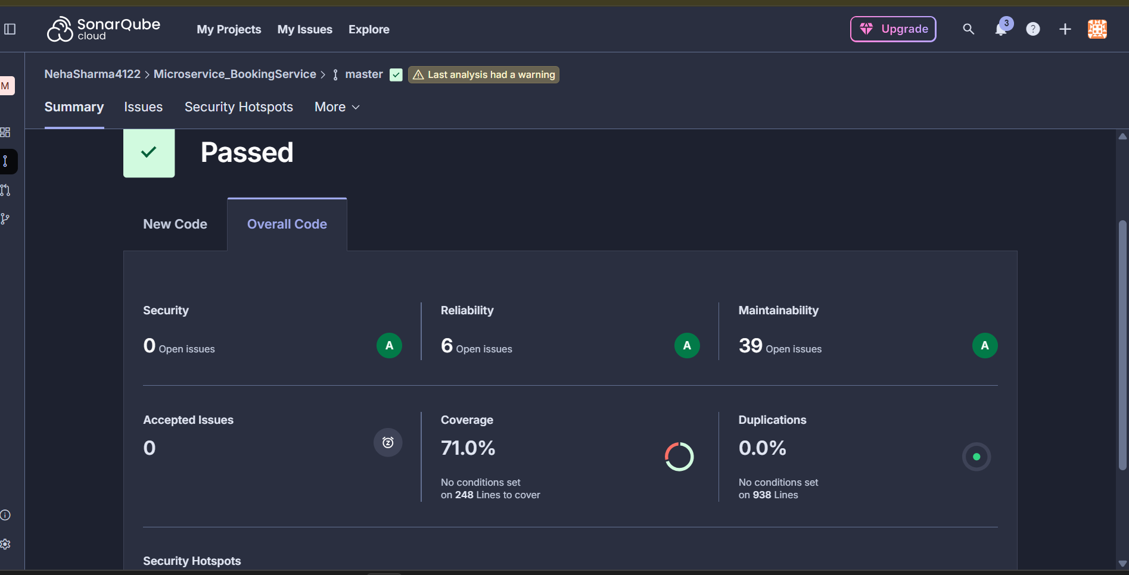

**10)JMETER TESTING**

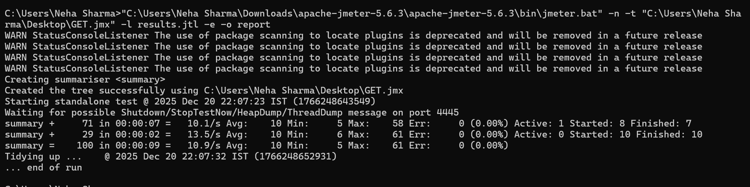

**11) CONFIG SERVER**

<https://github.com/NehaSharma4122/Microservices_configServer>